**Cairo University  
Faculty of Computers and Artificial Intelligence** 

**CS251**

**Introduction to Software Engineering**

Tharwa

Software Design Specifications

Version 1.5

|  |  |  |
| --- | --- | --- |
| Name | ID | Email |
| Fatema El-Zhraa Ahmed Mohamed El-Fiky | 20230280 | fatmaelfeky922@gmail.com |
| Nagham Wael Mohamed | 20231189 | naghamw63@gmail.com |
| Aly El-Deen Yasser Ali | 20231109 | ali.el.badry.747@gmail.com |

April of 2025

**Contents**

Team 3

Document Purpose and Audience 3

Purpose. 3

Audience. 3

System Models 5

I. Architecture Diagram 5

II. Class Diagram(s) 6

III. Class Descriptions 8

IV. Sequence diagrams 13

Class - Sequence Usage Table 14

V. State Diagram 16

VI. SOLID Principles 16

VII. Design Patterns 16

Tools 16

Ownership Report 16

# Team

|  |  |  |  |
| --- | --- | --- | --- |
| **ID** | **Name** | **Email** | **Mobile** |
| 20230280 | Fatema El-Zhraa Ahmed Mohamed El-Fiky | fatmaelfeky922@gmail.com | 01221990828 |
| 20231189 | Nagham Wael Mohamed | [naghamw63@gmail.com](mailto:naghamw63@gmail.com) | 01007600773 |
| 20231109 | Aly El-Deen Yasser Ali | ali.el.badry.747@gmail.com | 01286964627 |

# Document Purpose and Audience

## Purpose.

This SDS defines the design and structure of the Personal Investment Management Software. The software aims to help users track, analyze, and optimize their investment portfolios, ensuring informed financial decisions. It serves as a reference for consistent development, testing, and future improvements.

## Audience.

1. **Development Team**
   * Software Engineers/Developers: Backend and frontend developers who will implement the system architecture and codebase based on the design specifications.
   * Technical Leads: Senior developers who will oversee implementation and ensure alignment with design decisions.
   * QA Engineers: Testers who will use the design documentation to create test cases and verify system behavior.
2. **System Architects**
   * Professionals responsible for reviewing and approving the high-level system design and ensuring it meets all technical requirements.
3. **Project Stakeholders**
   * *Product Owners*: Non-technical stakeholders who need to understand how design decisions fulfill business requirements.
   * *Islamic Finance Experts*: Domain specialists who will verify Sharia-compliance aspects of the design.
   * *Banking Integration Partners*: Technical representatives from partner institutions (e.g., CIB) who need to understand integration points.
4. **Maintenance Team**
   * Future developers who will maintain, update, or extend the system and need comprehensive design documentation.

# System Models

## I. Architecture Diagram

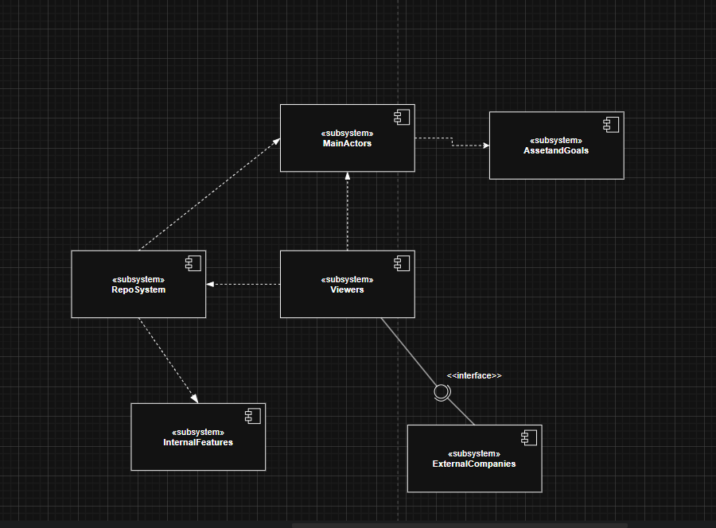

## II. Class Diagram(s)

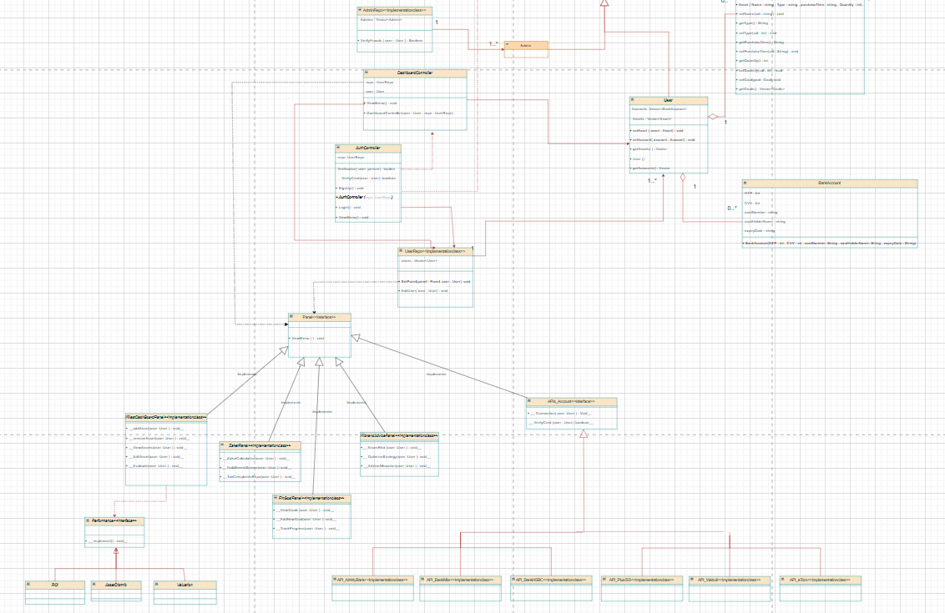

<https://drive.google.com/file/d/1ur9hwcOiEpEGw7NfDLpcxsdzo6gH-VJE/view?usp=sharing>

## III. Class Descriptions

| **ID** | **Class Name** | **Description & Responsibility** |
| --- | --- | --- |
| 1. | **Asset** | **Description**: Represents a financial asset (stocks, real estate, crypto, gold) in a user’s portfolio.  **Responsibilities**:   * Store asset details (Name, Type, Quantity, purchaseTime). * Link to financial goals (Goals: Vector<Goal>). |
| 2. | **Person** | **Description**: Base class storing common attributes for all human actors.  **Responsibilities**:   * Manage core attributes (Username, Name, Password, Email). |
| 3. | **User** (Extends Person) | **Description**: Represents an investor with linked assets and bank accounts.  **Responsibilities**:   * Maintain collections of Assets and BankAccounts (Accounts: Vector<BankAccount>). * Provide methods to fetch assets/accounts. |
| 4. | **BankAccount** | **Description**: Stores linked bank/card details for transactions.  **Responsibilities**:   * Secure sensitive data (OTP, CVV, cardNumber). |
| 5. | **Goal** | **Description**: Tracks financial objectives (e.g., retirement savings).  **Responsibilities**:   * Store goal metrics (targetAmount, deadline, currentProgress). * Update progress via setters (setProgress()). |
| 6. | **AuthController** | **Description**: Handles authentication and user sessions.  **Responsibilities**:   * Verify credentials (Verification(user: Person): boolean). * Manage signup/login flows (SignUp(), Login()). * Interact with UserRepo for persistence. |
| 7. | **ZakatPanel** (Interface) | **Description**: Defines contracts for Sharia-compliant zakat operations.  **Responsibilities**:   * Declare methods for zakat calculation (ZakatCalculation()). * Enforce halal screening (HalalInvestScreen()). |
| 8. | **RiskAndAdvicePanel** (Interface) | **Description**: Specifies risk assessment and investment advice features.  **Responsibilities**:   * Define risk analysis methods (AssetRisk()). * Outline strategy optimization (OptimizeStrategy()). |
| 9. | **FinGoalPanel** (Interface) | **Description**: Template for financial goal tools  **Responsibilities**:   * Declare goal tracking methods (ViewGoals(), TrackProgress()). * Support adding new goals (AddNewGoal()). |
| 10. | **Admin(Extends Person)** | **Description**  Represents an administrator in the system.  **Responsibilities:**  Potentially manage users, verify fraud activities, and oversee the system’s operations. |
| 11. | **AdminRepo<<Implementation>>** | **Description**  Represent the interface that the admin will interact with  Responsibilities:   * Check the Authorization of Admin License * Verify the Frauds of user (VerfiyFrauts (user : User)) |
| 12. | **DashboardController** | **Description**  Controls the interaction between the user and the system's dashboard, coordinating with user data through a repository.  **Responsibilities**   * Manage the current User session. * Handle user operations by interacting with the UserRepo. * Display the dashboard menu to the user using ViewMenu() |
| 13. | **UserRepo<Implementation>** | **Description**  Repository class that stores all system users and their associated bank APIs.  **Responsibilities:**   * Maintain a Vector of User objects and a reference to a Bank API. * Provide access to add new user data through the method addUser(User user). * Determine the panel that user will go to using setPanel() |
| 14. | **InvestDashboardPanel (Interface)** | **Description**  Interface defining user investment-related operations on the dashboard.  **Responsibilities:**   * + **Add new** assets to a user’s profile.   + Remove assets from a user’s profile.   + View a user's current assets.   + Edit user assets.   + Evaluate **the user's investment performance.** |
| 15. | **Performance (Interface)** | **Description:**  Interface for measuring different aspects of user performance.  **Responsibilities:**   * Define a common implement() method that will be customized for various performance evaluations like ROI (Return on Investment), Asset Distribution, and Valuation. |
|  | Api_Accounts | **Description:**  It is an interface that defines the standard operations required for connecting to and verifying user credentials across different financial account systems. It serves as a template to ensure that all financial service implementations follow a consistent structure for integration and authentication.  **Responsibility:**   * Specify a method to establish a connection between the user and the financial account (Connection(User user)). * Specify a method to verify the user's credentials (VerifyCred(User user)). * Enforce a unified protocol that must be followed by all implementing classes, such as API_AlAhlyBank, API_BankMisr, API_BankHSBC, API_Plus500, API_Webull, and API_eToro. * Allow flexibility for each financial API to provide its own specific connection and verification logic while maintaining a common interface. |

## IV. Sequence diagrams

Sign up Use case

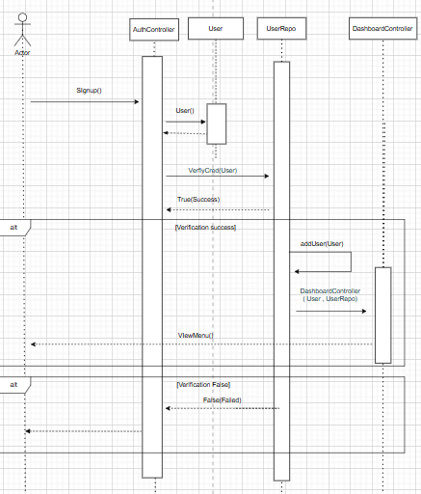

Login Use Case

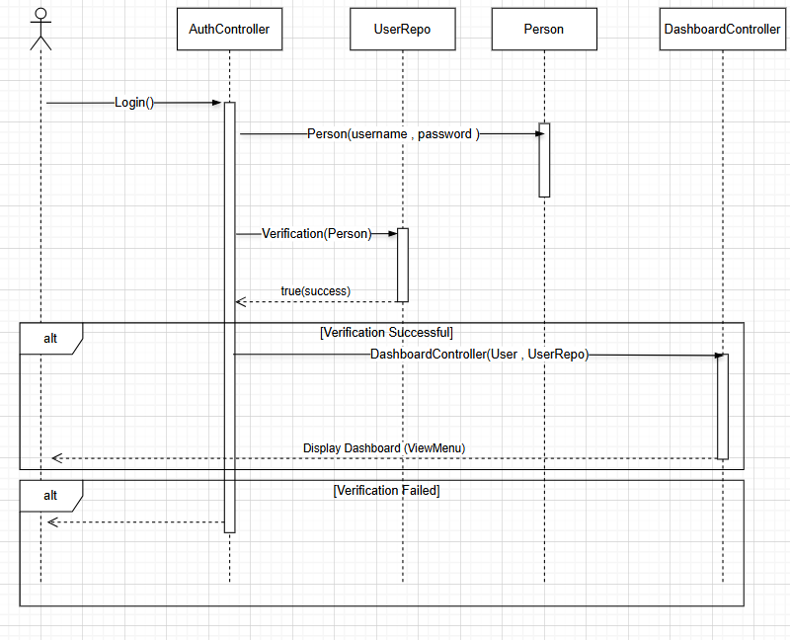

Add Assets Use Case.

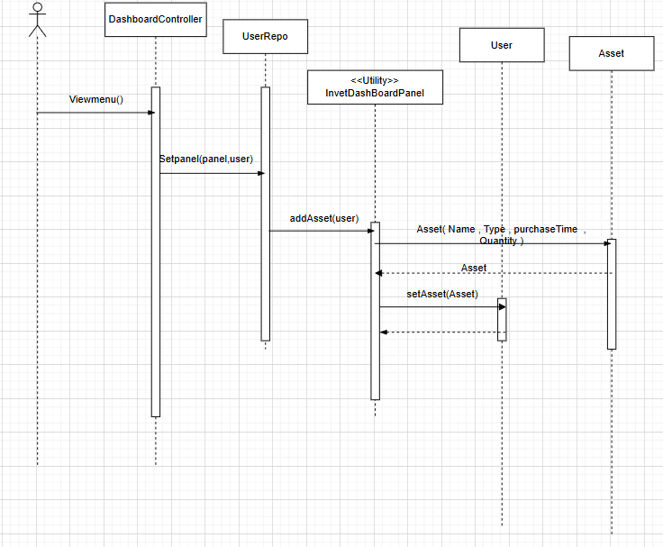

### Class - Sequence Usage Table

| **Sequence Diagram** | **Classes Used** | **All Methods Used** |
| --- | --- | --- |
| 1. Sign Up | Authcontroller  User  UserRepo  DashboardController | Signup()  User()  VeerifyCred(user)  addUser(user)  DashboardController(user, userRepo)  ViewMenu() |
| 1. Login | AuthController  UserRepo  Person  DashboardController | Login()  Verification(User : Person) |
| 1. AddAssets | DashBoardController  UserRepo  <<Utility>>InvestDashBoardPanel  User  Asset | Viewmenu()  Setpanel(panel,user)  addAsset(user)  Asset(Name,Type,purchaseTime , Quantity)  setAsset(Asset) |

## V. State Diagram

## VI. SOLID Principles

## 

## VII. Design Patterns

# 

# Tools

* Draw.io

# Ownership Report

|  |  |
| --- | --- |
| **Item** | **Owners** |
| Architecture Diagram, Part of Class Diagram, Add asset Sequence Diagram. | Fatema El-Zhraa Ahmed Mohamed El-Fiky |
| Part of Class Diagram , Sign up Sequence Diagram, File Organization,Purpose of SDS | Aly El-Deen Yasser Ali |
| Part of Class Diagram , login Sequence Diagram, Audience of SDS | Nagham Wael |